**Fact Sheet on MOLDOVA Map**

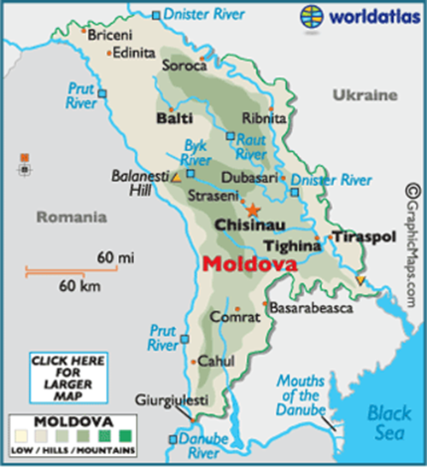

|  |  |
| --- | --- |
| **GENERAL** | |
| **Official Name** | Moldova |
| **Capital** | Chisinau |
| **Area** | 33,843 km² |
| **Population** | 2.512,758 million (2024 est.) |
| **Age profile (2022)** | 0-14 years: 19,5%  15-64 years: 63,6%  65 years and over: 16,9% (2025 est.) |
| **Life expectancy (2024)** | Total population: 71,9 years;  Male: 67,5 years;  Female: 76,4 years (2025 est.) |
| **Languages** | Romanian, also called Moldovan (official) 76,5%, |

|  |  |
| --- | --- |
|  | Russian (11,3%), Ukrainian (5,5%), Gagauz (4,1%) and Bulgarian 1,6% (2014 census) |
| **Ethnic groups** | Moldovan 75.1%, Romanian 7%, Ukrainian 6.6%, Gagauz 4.6%, Russian 4.1% and  Bulgarian 1.9% (2014 census) |
| **Religions** | Orthodox 90,14%; Protestant 0,9%; Jehovah's Witnesses 0,62%; 7th Day Adventist 0,32%; Catholic 0,1%; Old Believer 0,09%; other 7,83% (including Islam, Judaism, Agnostic etc.) |
| **Currency** | Moldovan leu |
| **GDP (2024)** | USD 16.7 billion (2024 est.) |
| **GDP Growth Rate** | 0.1% (2024); +1.2% (2023); 2.9% (2022); 5.5% (2021); 3.8% (2020 est.); |
| **Unemployment** | 4.0% (2024) ;3.1% (2023) ;3.2% (2022) ;3.8% (2021) ;4,71% (2020) |
| **Forest cover** | 11,8 % (2020 est.) |
| **CO2 emission per capita (2023)** | 3.3 metric t (2023 est.) |
| **Tourist arrival** | 504.000 (2023) ;162.000 (2022);178.000 (2021); |
| **Internet penetration (2024)** | 63% (2024 est.) |
| **Mobile phones connections (2022)** | 3,86 million connections (2025 est.); percent of population: 128% (2025 est.) |
| **Urbanization (2023)** | 46,4% (2024) |
| **Moldova’s Global Exports (2023)** | US$ 4.33 billion exports (2022) [goods] + USD 1.6 billion (2021) [services] |
| **Moldova’s Global Imports (2023)** | US$ 9.21 billion exports (2022) [goods] + USD 1.1 billion (2021) [services] |
| **Main trade partners of Moldova** | Main export partners: Romania (28.6%), Ukraine (16.6 %), Italy (7.6%), Turkey (7%), Germany (5.3%), Russia (4.4%)  Main import partners: Romania [mineral oil & machinery], Ukraine [oil, seeds, wood], Russia [oil and gas], Germany, Italy, China, Turkey and Poland |
| **Political** | |
| **Political Structure** | A multiparty democracy, PM head of govt, Parliament has 101 members elected for a 4year term, President, designates a candidate for PM. In June 2022, Moldova has been granted EU candidate status by the European Parliament |
| **Head of State** | President H.E. Ms. Maia Sandu since 24 December 2020 |
| **Head of Government (Prime** | Prime Minister H.E. Mr. Dorin Recean since February 2023 |

|  |  |
| --- | --- |
| **Minister)** |  |
| **Minister for Foreign Affairs** | H.E. Mr. Mihai Popșoi since January 2-24 |
| **Bilateral** | |
| **Bilateral trade with Moldova** | US$ 12.58 million (2020-21)  US$ 9.12 million (2021-22)  US$ 15.89 million (2022-2023)  US$ 16.75 million (2023-2024) |
| **Indian Exports to Moldova** | US$ 11.58 million (2020-21)  US$ 9.03 million (2021-22)  US$ 11.96 million (2022-23)  US$ 12.51 million (2023-2024) |
| **Indian Imports from Moldova** | US$ 1.00 million (2020-21)  US$ 0.09 million (2021-22)  US$ 3.93 million (2022-23)  US$ 4.24 million (2023-2024) |
| **Moldova’s main products of Export to India in 2025** | Main articles of Indian imports from Moldova include a variety of products such as animal or vegetable fats and oils and their cleavage products, prepared edible fats, and animal or vegetable waxes, Cereals, optical, photographic, cinematographic, measuring, checking precision, medical or surgical instruments and apparatus, along with their parts and accessories |
| **Moldova’s main products of Import from India in 2025** | Major articles of export to Moldova include a wide range of products. These encompass drugs and pharmaceutical products, engineering goods, ceramic products and glassware, organic and inorganic chemicals etc. |
| **Indian investments in Romania** | US$ 46 million (estimated) |
| **Romania investments in India** | US$ 14 million (estimated) |
| **Indian Community** | Total: Around 1450., including approx. 1270 medical students. |

**As on 11 June, 2025**